MANAGEMENT BUDGET

Only few GMC-players understand how to use the management budget (MB) to increase the efficiency of production, because it is not clearly marked in the official manual and extremely difficult to test in practice. But if you have a couple of thousand reports, then making correct analysis is a matter of technique.

The strongest influence MB provides on:

1．Decreasing % of broken parts in the manufacture. Decreasing % of broken parts is not high and slightly affects on company, but will be a nice addition to financial result.

2．Decreasing force majeure. Information about influence in detail you can read in this article.

3．Market grows.

According to the results of numerous experiments, the optimal value of MB is about 13-14% of the overhead costs, the optimum should be predicted for all 5 periods as a constant and set in the 1 decision.

**Test 1 - scenario 12C1**

Increasing MB 180 to 200 (from 14.6% to 16.2% of the overhead costs):  
1 period - market grows by 1.5% compared with 5 history report (⅔ effect)  
2 period - market grows by 2.2% compared with 5 history report (full effect)  
3 period - market grows by 2.6% compared with 5 history report

**Test 2 - scenario 12C1**

Increasing MB 180 to 220 (from 14.6% to 17.7% of the overhead costs):  
1 period - market grows by 2.9% compared with 5 history report (⅔ effect)  
2 period - market grows by 4.5% compared with 5 history report (full effect)  
3 period - market grows by 5.1% compared with 5 history report

**Test 3 - scenario 12C1**

Increasing MB in 1 period. Vertical - the relative market change compared with 5 history report. Horizontal - the absolute values of MB.

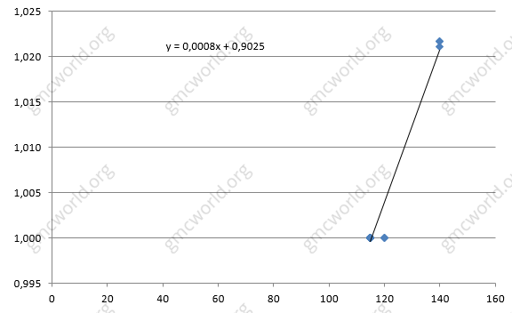

**Test 4 - 12C3 script**

A similar graph for scenario 12C3, increasing MB in the 1 period.

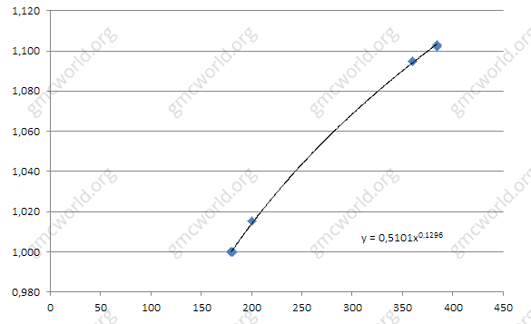

**Hints**

1．Market grows in scenario 12C1 and 12C3 practically identical, which means that MB-function does not depend on scenario and competitors in the group. So it refers to the internal factors of the company.

2．MB has ⅔ from full effect in the current period, the full effect occurs in the next period. Effect of competitors is absent or it is insignificant.

3．Market growth is equal for all markets and products.

管理预算

只有少数GMC玩家了解如何使用管理预算（MB）来提高生产效率，因为在官方手册中没有明确标注，在实践中极难测试。 但是如果你有几千个报告，那么进行正确的分析就是一个技术问题。

管理预算提供的最强影响力：

1．制造中废品的百分比下降。废品的减少率不高，对公司影响稍微小一些，但对财务业绩来说也是一个很好的补充。

2．减少不可抗力。有关影响的详细信息，请参阅本文。.

3．市场增长。

根据大量实验的结果，管理预算的最优值约占间接成本的13-14％，所有5个周期的最优应该是一个常数，并在第一期决定中设定。

**测试1 - 情景12C1**

将管理预算从180增加到200（从间接成本的14.6％增加到16.2％）：

第1期 - 市场增长1.5%相比于历史5（2/3效果）

第2期 - 市场增长2.2%相比于历史5（全部效果）

第2期 - 市场增长2.6%相比于历史5

**测试2 - 情景12C1**

 将管理预算从180增加到2220（从间接成本的14.6％增加到17.7％）：

第1期 - 市场增长2.9%相比于历史5（2/3效果）

第2期 - 市场增长4.5%相比于历史5（全部效果）

第2期 - 市场增长5.1%相比于历史5

**测试3- 情景12C1**

第一期增加管理预算。 垂直－相对市场变化与5历史报告相比。 水平－MB的绝对值。



**测试4 - 12C3脚本**

情景12C3的类似图表，在第一期增加了管理预算。



**提示**

1．场景12C1和12C3的市场增长情况几乎相同，这意味着管理预算功能不依赖于组中的场景和竞争对手。所以指的是公司的内部因素。

2．管理预算在当期发挥全面作用的2/3，下一个时期发挥全面发生。竞争对手的影响不存在或者说是微不足道的。

3．市场增长是相等的对于所有市场和产品。